

Day -4: Pattern Programs (1-17)

Name: M. Sahasra
Reg. No.: 192425317
Course Code: CSA0919
Course Name: Programming in Java for Spring Framework
Faculty Name: Dr. Magesh Kumar

- Right-Angled Triangle of Stars

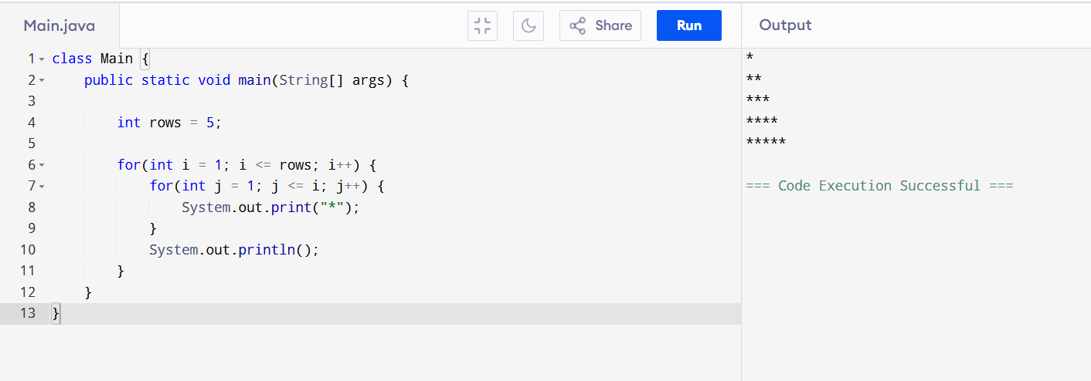

- Number Pyramid
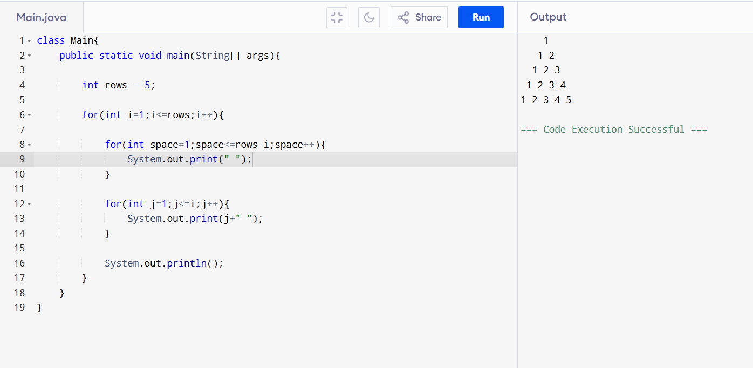
- Hollow Square Pattern
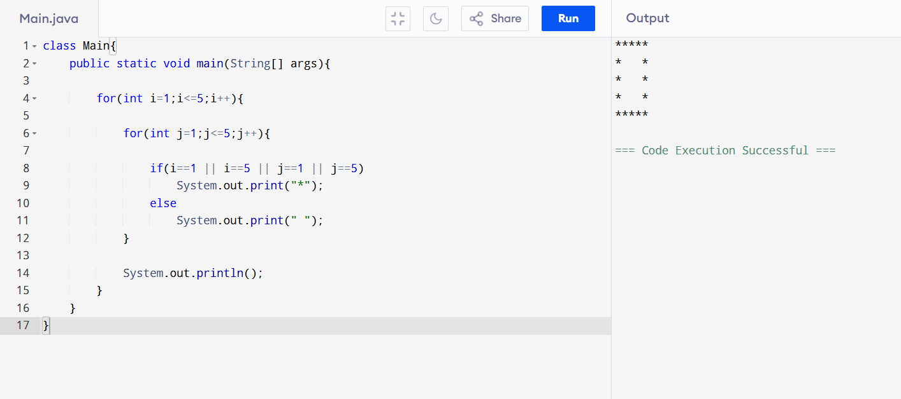
- Number Right-Angled Triangle
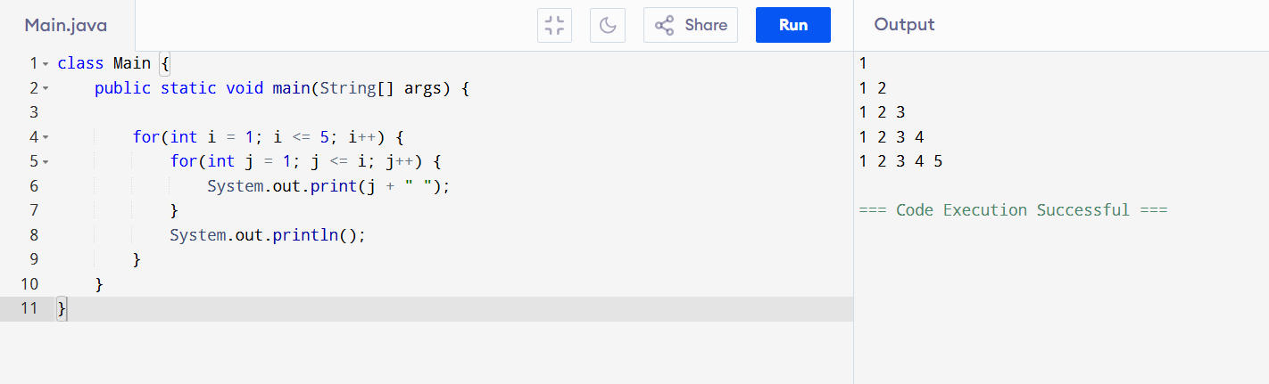

- Alphabet Triangle

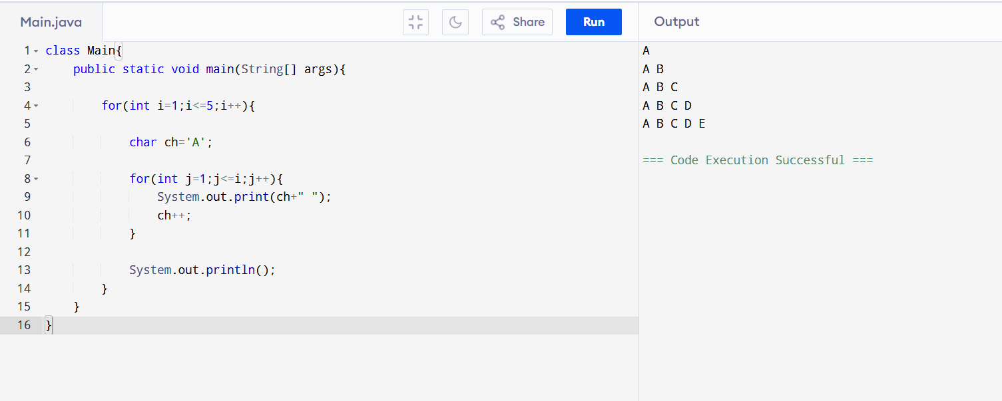

- Diamond Star Pattern

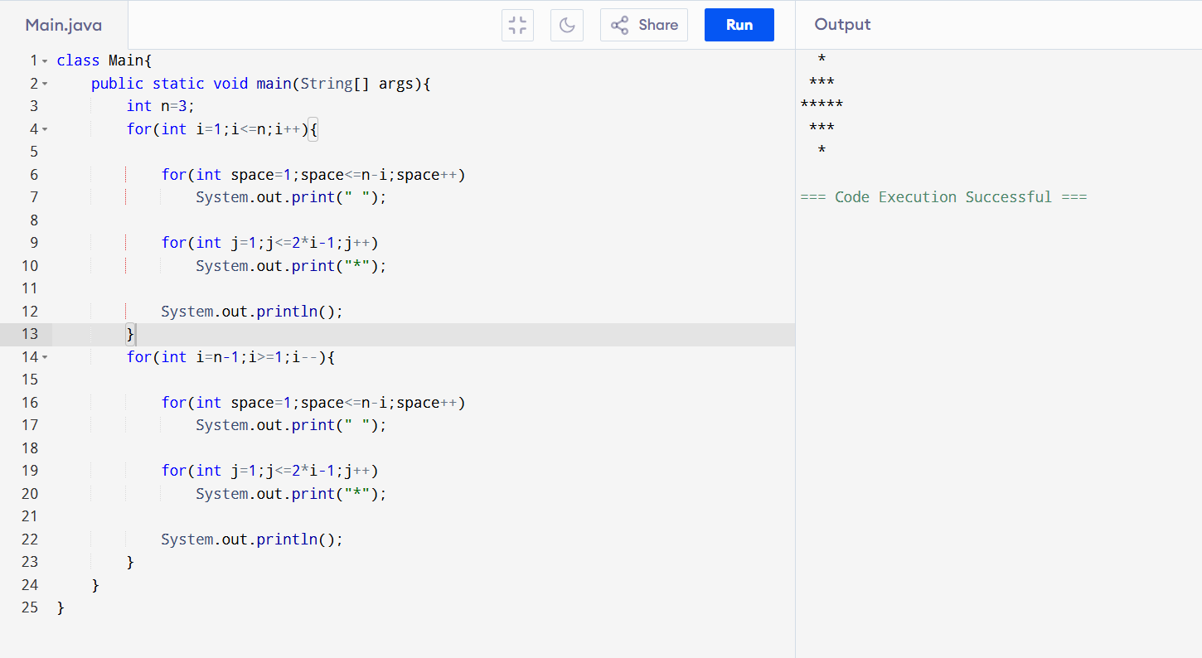

- Floyd’s Triangle
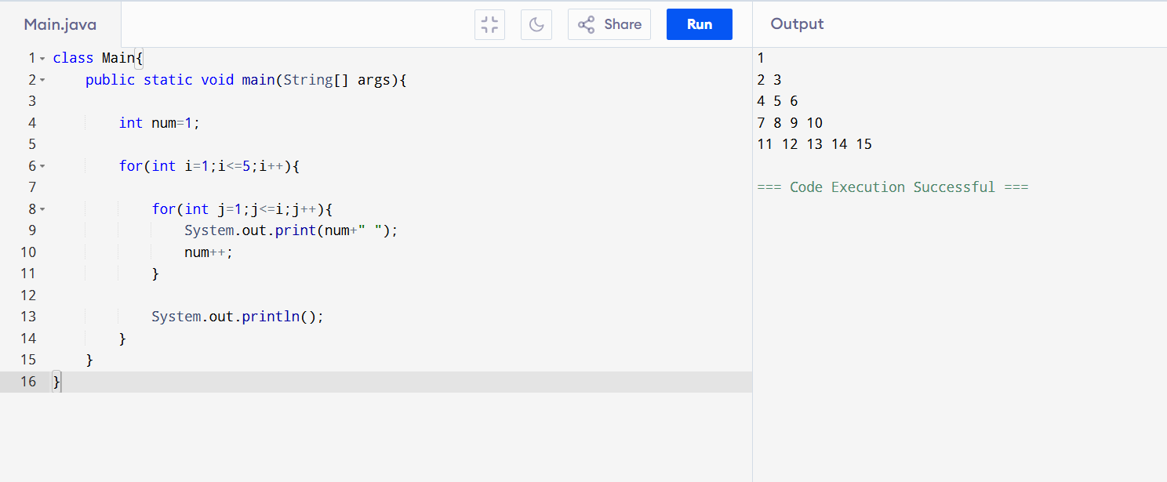
- Right-Aligned Star Triangle
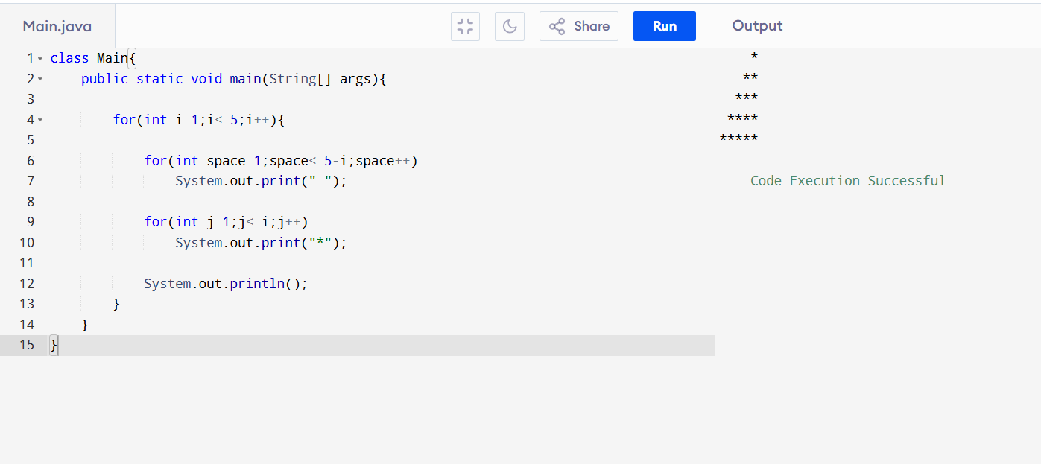
- Inverted Number Triangle
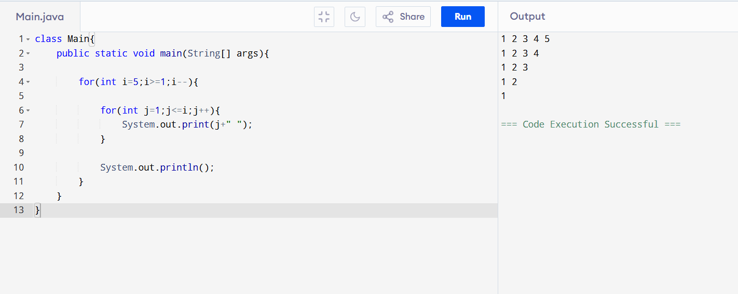

- Binary Number Triangle
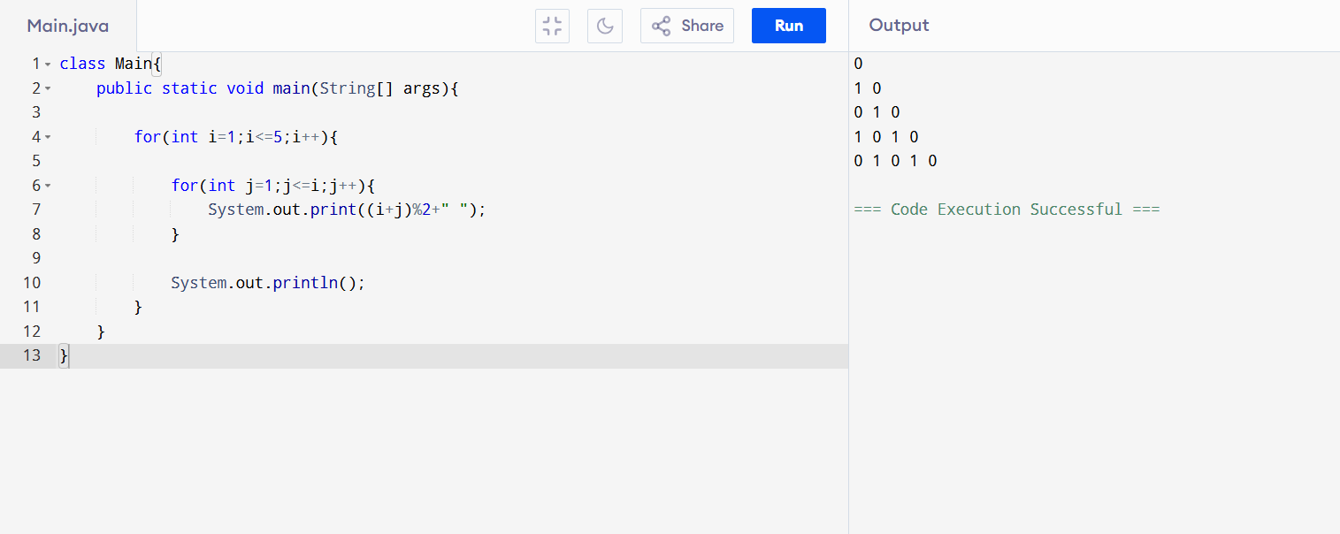
- Half Diamond Star Pattern
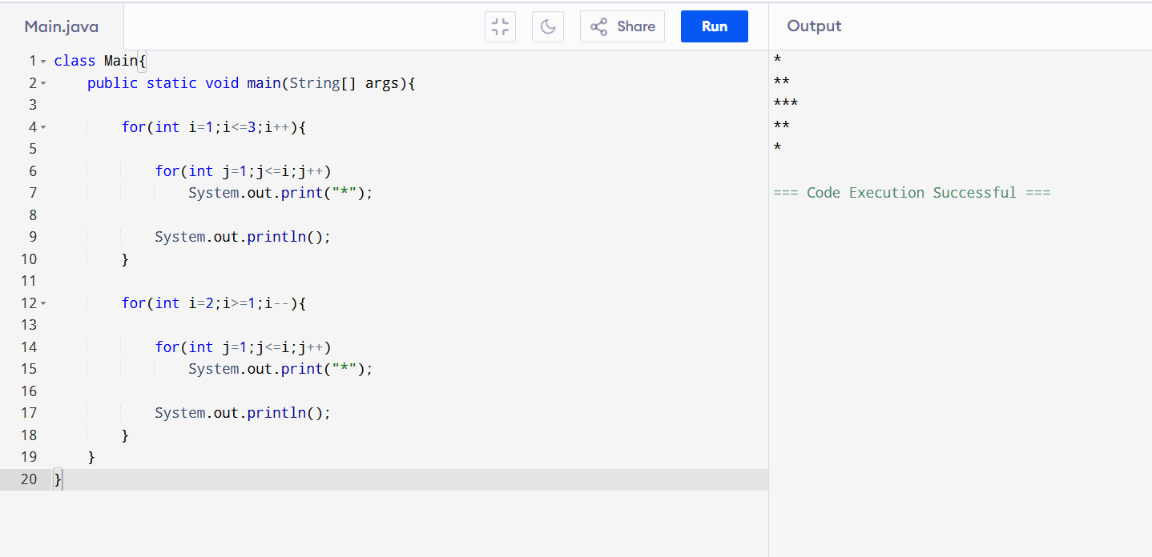
- Hollow Right-Angled Triangle
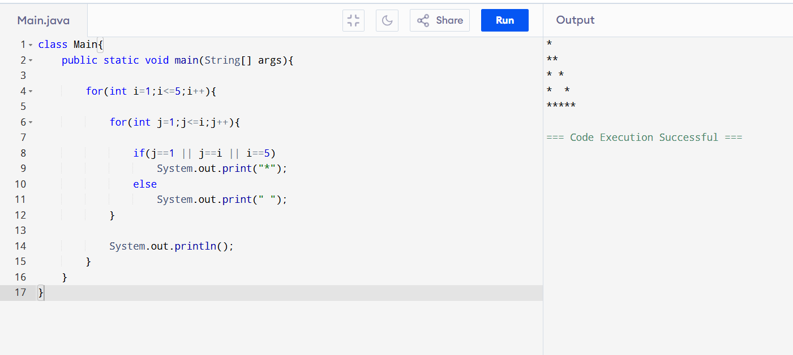
- Reverse Pyramid of Stars
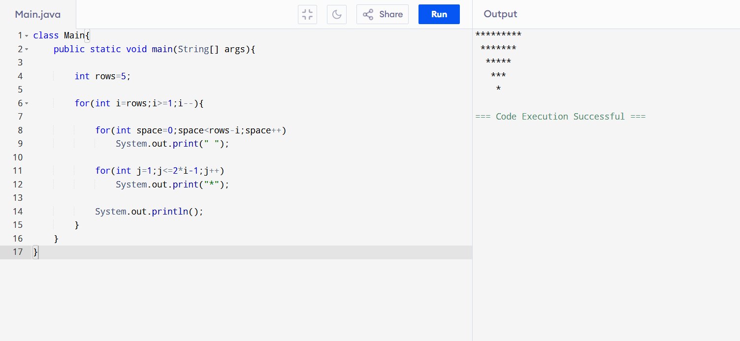
- Continuous Characters Triangle
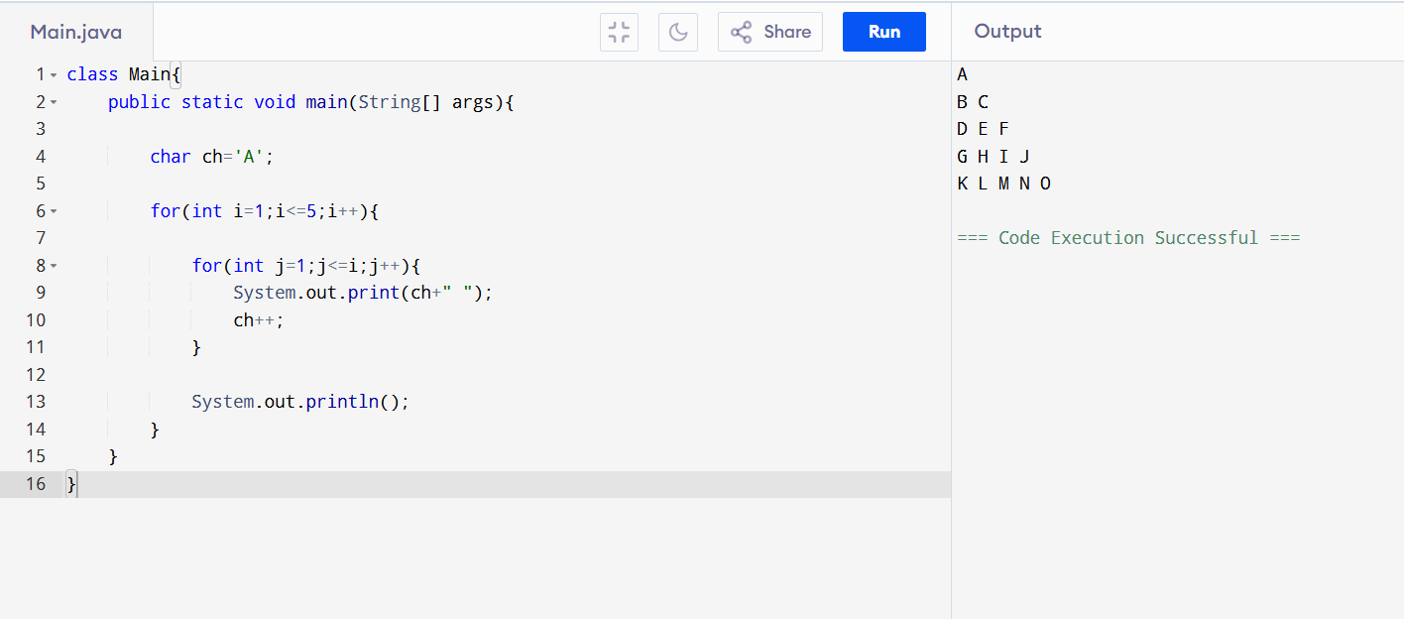
- Right-Angled Triangle with Even Numbers
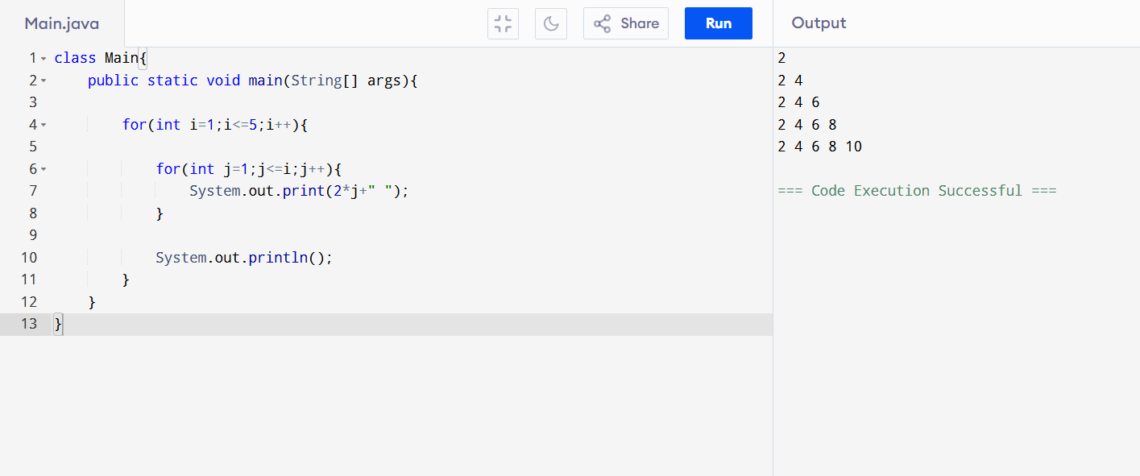
- Triangle of Odd Numbers

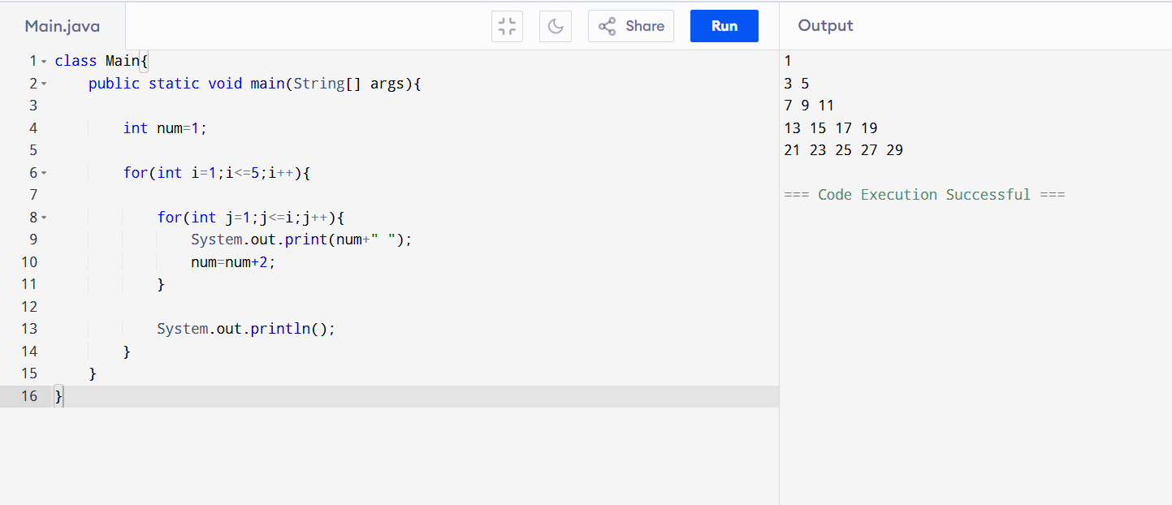
- Hollow Pyramid Pattern
